
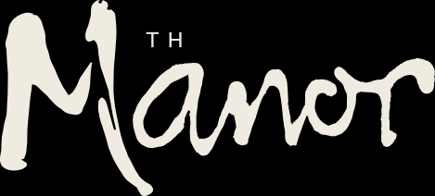

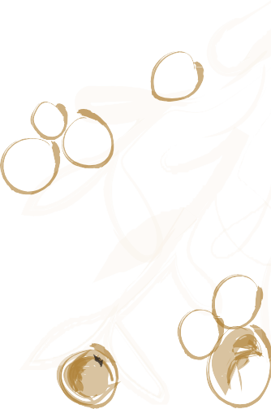

L TTLE PEOPLE AT THE MANOR HOUSE
Portions are suitable for children up to 10 years old
(Older Children may wish to choose from the main menu)


STARTER

Garlic bread or Cheesy garlic bread0 £5

MA NS

Sausages, fries & gravy £8.50

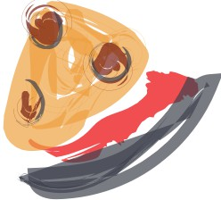
Chicken skewers, salad & fries e £8.50 Mini battered fish, chips & mushy peas e £8.50 9" Margherita Pizza G can be G £7.50
9" Pepperoni pizza £8.50

SUNDAY ROASTS (SUNDAYS ONLY)
with Roast potatoes vegetables and gravy

Half roast chicken supreme0 Roast Beef and Yorkshire pudding
£9
£10


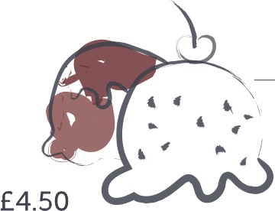
PUDD NGS

and gravy
with Roast potatoes vegetables

Two scoops of ice cream G 0
Choose from: Vanilla, Chocolate, or Strawberry
Sticky Toffee Pudding & vanilla ice cream G £4.50
Fresh melon and mango sorbet G £4.50

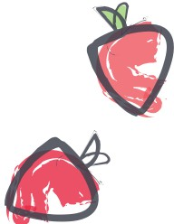
DR N KS
we are happy to offer just water to children or you can order

Innocent Strawberry & Raspberries or Apple smoothie - £2.50 Cawston Press Apple & Pear or Apple & Mango juice drinks - £2.50 Fruit Shoots, Orange or Apple & Blackcurrant - £2.50

Thanks for coming to us. If you have any allergies or dietary requirements, please let us know on your arrival.
G = Vegetarian fl = Vegan O = Can be gluten free O = Gluten free 0 = Contains nuts

